After reviewing the results with the customer we would like to make the following adjustments.

* **Logic for Email Duplicates:** Can you update the logic to only identify duplicates if the email matches AND first name matches? Example below are two records that have the same email, but different first names (husband and wife business). With the added logic, those would not be picked up as duplicates.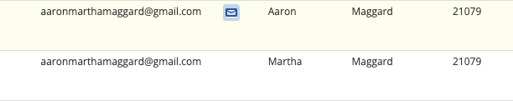
* **Add to Results:** We want to add the following fields to the results:
  + **Verified from RETS Feed (custrecord_verified_from_rets_agent):**  We want to add this field from the Agent record to the results in the Update to Agents custom table.
  + **CRM Record Count:** On the Agent record there is a sub tab titled Inquiries Made and then another sub tab under that titled CRM Records. We want to create a result in the custom table that will give a count, by agent, for how many records exist here. Here is a saved search that can be used to determine the count: <https://1309901.app.netsuite.com/app/common/search/searchresults.nl?searchid=1204&saverun=T&whence=>

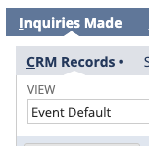

* **Survey Count:** On the Agent record there is a sub tab titled Inquiries Made and then another sub tab under that titled Survey - Real Estate Agent. We want to have a result column added to the custom table that will show the count, by agent, for how many Surveys they have. Here is a saved search that can be used to determine the count: <https://1309901.app.netsuite.com/app/common/search/searchresults.nl?searchid=1205&saverun=T&whence=>

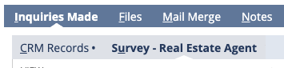

* **Sold Properties:** On the Agent record there is a sub tab titled Sold Properties. We want to have a result column added to the custom table that will show the count, by agent, for how many Sold Properties they have. Here is a saved search that can be used to determine the count: <https://1309901.app.netsuite.com/app/common/search/searchresults.nl?searchid=1205&saverun=T&whence=>

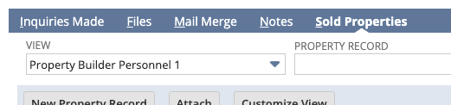

* Create a new ‘checkbox’ field titled Keep.
* Create a new ‘checkbox’ field titled Purge.
* Create a new ‘free form text’ field titled Master ID.